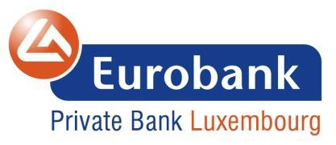

Eurobank Private Bank Luxembourg S.A. is engaged in the business of providing Private Banking, Wealth Management, Investment and Advisory services for corporate and private clients. In order to reinforce its team, our Bank is currently looking for a:

Private Banking Trainee (m/f)

The Private Banking mission is to provide exclusive service and tailor made solutions to High Net Worth Individuals, Family Offices and institutional and corporate clients in a highly competitive and global environment.

The trainee position offers an opportunity for interaction and exposure with relevant units of the Bank and the Group, acquisition of knowledge on all Private Banking related developments, and career development in a growing Bank, situated in one of the most stable and financially prominent centers of the European Union.

Main Duties and Responsibilities:

- Provide assistance, support and back-up to the PB Associates and Client Relationship Officers (CRO)
- End to end servicing and administration of account opening and execution of trades for current and prospective customers.
- Support and delivery of business requests coming from Eurobank Athens Private Banking teams for their respective clients.
- Acts as the main point of contact for a portfolio of clients dealing with day-to-day banking across the range of services and products within Private Banking under close surveillance of supporting CRO.
- Responds in a timely and professional manner to clients’ requests, owning task execution end to end, working pro-actively with Treasury, Dealing, Credit, Compliance and Operations to ensure delivery, to resolve issues and reduce errors
- Keeps Private Bankers accurately and on time informed on client interaction and shares any insights gained through client servicing, while maintains an up-to-date knowledge on financial- markets and macro-economic environment

Qualifications:

- Education: Master's degree preferably in Banking, Finance or Business Administration

- Competencies: Willingness for achieving results and continuously improving performance, teamwork spirit and strong interpersonal skills, ability to understand and analyze customer needs
- Skills: Strong communication and presentation skills (both written & verbal), good numerical and data analytics skills, computer literacy (Excel, MS office)
- Languages: Fluent English

Contact Information
Email : recruitment@eurobankpb.lu

