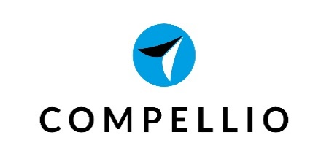
Job Description – Content Marketing Internship
Compellio is looking for a talented postgraduate degree holder to actively support our inbound marketing strategies including social media, newsletters, blogs and lead generation. The Content Marketing intern will be part of an agile development team building and working on enterprise software applications. The intern will be involved in all areas of content marketing, from design and development to testing and analysis.
About Compellio
Compellio (http://compell.io/en) is a business modelling software that aims at helping entrepreneurs to define, develop and validate their business ideas. Developed by a passionate team of Greek entrepreneurs, incubator managers and early-stage investors, Compellio leverages state-of‐the-art methodologies that allow founders or founding teams to work in a dedicated and secure space to accelerate their entrepreneurial and innovation projects.
Duties and Responsibilities
The duties and responsibilities of the Content Marketing intern include:
- Design, develop and test content marketing strategies and set short-term goals
- Undertake content marketing initiatives to achieve business targets
- Collaborate with design and writing teams to produce high quality content
- Develop editorial calendar and ensure deadlines are met
- Deliver engaging content on a regular basis and inspire team members
- Edit, proofread and improve content
- Optimize content considering SEO and Google Analytics
- Analyze web traffic metrics and social media metrics
- Receive customer feedback and generate ideas to increase customer engagement
- Support business users with their marketing strategy and activities
Desired Skills & Experience
Our ideal candidate is a creative marketing postgraduate degree holder, preferably with a writing background. He/she should be able to develop engaging content to attract and retain customers. For this position, it’s also essential to be up-to-date with modern entrepreneurship methodologies (Business model canvas, Lean startup, Design thinking, Impact investing, etc.), marketing trends and new technologies.
- Proficiency in MS Office and WordPress or other Content Management Software
- Understanding of web publishing requirements
- Editorial mindset with an ability to predict audience preferences
- Experience in video production and photo editing will be considered an asset
- Hands on experience with SEO and web traffic metrics
- Expertise in social media platforms
- Project management skills and attention to detail
- Excellent communication and writing skills in English
- Master’s degree in Marketing, Journalism or relevant field
Interested in an internship position at Compellio? Hope to hear from you soon.

